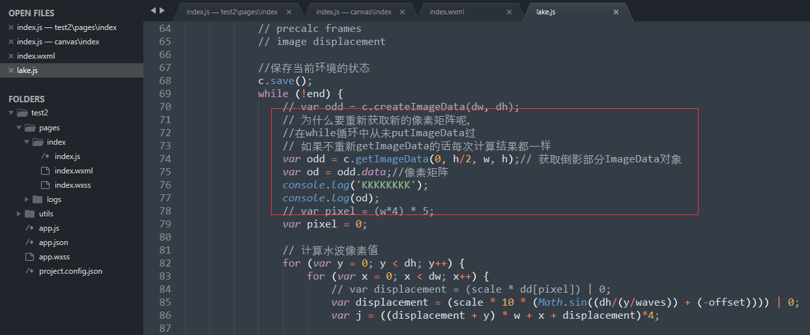

图 1

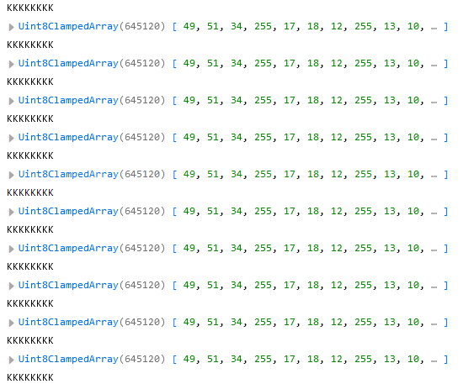

图 2

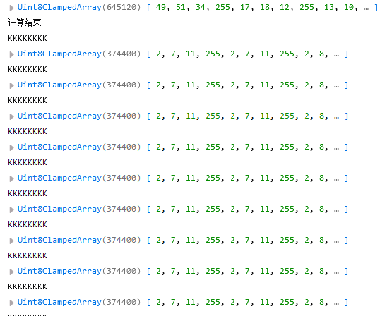

图 3

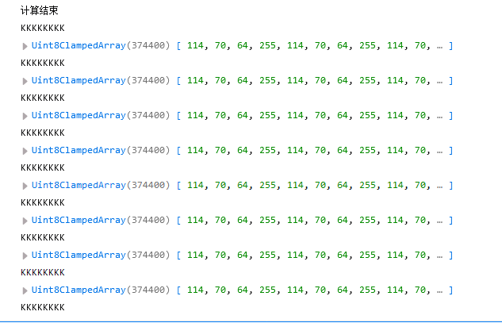

图 4

总共就只有三组数据，每一组数据对应一张图片

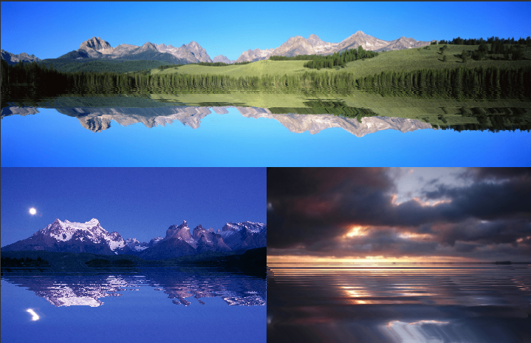

图 5

果然在while循环中获得像素矩阵都是一样的。



Uint8ClampedArray(645120) [ 49, 51, 34, 255, 17, 18, 12, 255, 13, 10, … ]

[lake.js:77:17](file:///F:\shuibo\jq22jQuery-lake119120161109\jQuery-lake\js\lake.js)

Uint8ClampedArray(645120) [ 49, 51, 34, 255, 17, 18, 12, 255, 13, 10, … ]

[lake.js:77:17](file:///F:\shuibo\jq22jQuery-lake119120161109\jQuery-lake\js\lake.js)

Uint8ClampedArray(645120) [ 49, 51, 34, 255, 17, 18, 12, 255, 13, 10, … ]

[lake.js:77:17](file:///F:\shuibo\jq22jQuery-lake119120161109\jQuery-lake\js\lake.js)

Uint8ClampedArray(645120) [ 49, 51, 34, 255, 17, 18, 12, 255, 13, 10, … ]

[lake.js:77:17](file:///F:\shuibo\jq22jQuery-lake119120161109\jQuery-lake\js\lake.js)

Uint8ClampedArray(645120) [ 49, 51, 34, 255, 17, 18, 12, 255, 13, 10, … ]

[lake.js:77:17](file:///F:\shuibo\jq22jQuery-lake119120161109\jQuery-lake\js\lake.js)

Uint8ClampedArray(645120) [ 49, 51, 34, 255, 17, 18, 12, 255, 13, 10, … ]

[lake.js:77:17](file:///F:\shuibo\jq22jQuery-lake119120161109\jQuery-lake\js\lake.js)

Uint8ClampedArray(645120) [ 49, 51, 34, 255, 17, 18, 12, 255, 13, 10, … ]

[lake.js:77:17](file:///F:\shuibo\jq22jQuery-lake119120161109\jQuery-lake\js\lake.js)

Uint8ClampedArray(645120) [ 49, 51, 34, 255, 17, 18, 12, 255, 13, 10, … ]

[lake.js:77:17](file:///F:\shuibo\jq22jQuery-lake119120161109\jQuery-lake\js\lake.js)

Uint8ClampedArray(645120) [ 49, 51, 34, 255, 17, 18, 12, 255, 13, 10, … ]

[lake.js:77:17](file:///F:\shuibo\jq22jQuery-lake119120161109\jQuery-lake\js\lake.js)

Uint8ClampedArray(645120) [ 49, 51, 34, 255, 17, 18, 12, 255, 13, 10, … ]

[lake.js:77:17](file:///F:\shuibo\jq22jQuery-lake119120161109\jQuery-lake\js\lake.js)

Uint8ClampedArray(645120) [ 49, 51, 34, 255, 17, 18, 12, 255, 13, 10, … ]

[lake.js:77:17](file:///F:\shuibo\jq22jQuery-lake119120161109\jQuery-lake\js\lake.js)

Uint8ClampedArray(645120) [ 49, 51, 34, 255, 17, 18, 12, 255, 13, 10, … ]

[lake.js:77:17](file:///F:\shuibo\jq22jQuery-lake119120161109\jQuery-lake\js\lake.js)

Uint8ClampedArray(645120) [ 49, 51, 34, 255, 17, 18, 12, 255, 13, 10, … ]

[lake.js:77:17](file:///F:\shuibo\jq22jQuery-lake119120161109\jQuery-lake\js\lake.js)

Uint8ClampedArray(645120) [ 49, 51, 34, 255, 17, 18, 12, 255, 13, 10, … ]

[lake.js:77:17](file:///F:\shuibo\jq22jQuery-lake119120161109\jQuery-lake\js\lake.js)

Uint8ClampedArray(645120) [ 49, 51, 34, 255, 17, 18, 12, 255, 13, 10, … ]

[lake.js:77:17](file:///F:\shuibo\jq22jQuery-lake119120161109\jQuery-lake\js\lake.js)

Uint8ClampedArray(645120) [ 49, 51, 34, 255, 17, 18, 12, 255, 13, 10, … ]

[lake.js:77:17](file:///F:\shuibo\jq22jQuery-lake119120161109\jQuery-lake\js\lake.js)

Uint8ClampedArray(645120) [ 49, 51, 34, 255, 17, 18, 12, 255, 13, 10, … ]

[lake.js:77:17](file:///F:\shuibo\jq22jQuery-lake119120161109\jQuery-lake\js\lake.js)

Uint8ClampedArray(645120) [ 49, 51, 34, 255, 17, 18, 12, 255, 13, 10, … ]

[lake.js:77:17](file:///F:\shuibo\jq22jQuery-lake119120161109\jQuery-lake\js\lake.js)

Uint8ClampedArray(645120) [ 49, 51, 34, 255, 17, 18, 12, 255, 13, 10, … ]

[lake.js:77:17](file:///F:\shuibo\jq22jQuery-lake119120161109\jQuery-lake\js\lake.js)

Uint8ClampedArray(645120) [ 49, 51, 34, 255, 17, 18, 12, 255, 13, 10, … ]

[lake.js:77:17](file:///F:\shuibo\jq22jQuery-lake119120161109\jQuery-lake\js\lake.js)

Uint8ClampedArray(645120) [ 49, 51, 34, 255, 17, 18, 12, 255, 13, 10, … ]

[lake.js:77:17](file:///F:\shuibo\jq22jQuery-lake119120161109\jQuery-lake\js\lake.js)

Uint8ClampedArray(645120) [ 49, 51, 34, 255, 17, 18, 12, 255, 13, 10, … ]

[lake.js:77:17](file:///F:\shuibo\jq22jQuery-lake119120161109\jQuery-lake\js\lake.js)

Uint8ClampedArray(645120) [ 49, 51, 34, 255, 17, 18, 12, 255, 13, 10, … ]

[lake.js:77:17](file:///F:\shuibo\jq22jQuery-lake119120161109\jQuery-lake\js\lake.js)

Uint8ClampedArray(645120) [ 49, 51, 34, 255, 17, 18, 12, 255, 13, 10, … ]

[lake.js:77:17](file:///F:\shuibo\jq22jQuery-lake119120161109\jQuery-lake\js\lake.js)

Uint8ClampedArray(645120) [ 49, 51, 34, 255, 17, 18, 12, 255, 13, 10, … ]

[lake.js:77:17](file:///F:\shuibo\jq22jQuery-lake119120161109\jQuery-lake\js\lake.js)

Uint8ClampedArray(645120) [ 49, 51, 34, 255, 17, 18, 12, 255, 13, 10, … ]

[lake.js:77:17](file:///F:\shuibo\jq22jQuery-lake119120161109\jQuery-lake\js\lake.js)

计算结束

第一组数据共26个

计算结束 [lake.js:142:13](file:///F:\shuibo\jq22jQuery-lake119120161109\jQuery-lake\js\lake.js)

Uint8ClampedArray(374400) [ 2, 7, 11, 255, 2, 7, 11, 255, 2, 8, … ]

[lake.js:77:17](file:///F:\shuibo\jq22jQuery-lake119120161109\jQuery-lake\js\lake.js)

Uint8ClampedArray(374400) [ 2, 7, 11, 255, 2, 7, 11, 255, 2, 8, … ]

[lake.js:77:17](file:///F:\shuibo\jq22jQuery-lake119120161109\jQuery-lake\js\lake.js)

Uint8ClampedArray(374400) [ 2, 7, 11, 255, 2, 7, 11, 255, 2, 8, … ]

[lake.js:77:17](file:///F:\shuibo\jq22jQuery-lake119120161109\jQuery-lake\js\lake.js)

Uint8ClampedArray(374400) [ 2, 7, 11, 255, 2, 7, 11, 255, 2, 8, … ]

[lake.js:77:17](file:///F:\shuibo\jq22jQuery-lake119120161109\jQuery-lake\js\lake.js)

Uint8ClampedArray(374400) [ 2, 7, 11, 255, 2, 7, 11, 255, 2, 8, … ]

[lake.js:77:17](file:///F:\shuibo\jq22jQuery-lake119120161109\jQuery-lake\js\lake.js)

Uint8ClampedArray(374400) [ 2, 7, 11, 255, 2, 7, 11, 255, 2, 8, … ]

[lake.js:77:17](file:///F:\shuibo\jq22jQuery-lake119120161109\jQuery-lake\js\lake.js)

Uint8ClampedArray(374400) [ 2, 7, 11, 255, 2, 7, 11, 255, 2, 8, … ]

[lake.js:77:17](file:///F:\shuibo\jq22jQuery-lake119120161109\jQuery-lake\js\lake.js)

Uint8ClampedArray(374400) [ 2, 7, 11, 255, 2, 7, 11, 255, 2, 8, … ]

[lake.js:77:17](file:///F:\shuibo\jq22jQuery-lake119120161109\jQuery-lake\js\lake.js)

Uint8ClampedArray(374400) [ 2, 7, 11, 255, 2, 7, 11, 255, 2, 8, … ]

[lake.js:77:17](file:///F:\shuibo\jq22jQuery-lake119120161109\jQuery-lake\js\lake.js)

Uint8ClampedArray(374400) [ 2, 7, 11, 255, 2, 7, 11, 255, 2, 8, … ]

[lake.js:77:17](file:///F:\shuibo\jq22jQuery-lake119120161109\jQuery-lake\js\lake.js)

Uint8ClampedArray(374400) [ 2, 7, 11, 255, 2, 7, 11, 255, 2, 8, … ]

[lake.js:77:17](file:///F:\shuibo\jq22jQuery-lake119120161109\jQuery-lake\js\lake.js)

Uint8ClampedArray(374400) [ 2, 7, 11, 255, 2, 7, 11, 255, 2, 8, … ]

[lake.js:77:17](file:///F:\shuibo\jq22jQuery-lake119120161109\jQuery-lake\js\lake.js)

Uint8ClampedArray(374400) [ 2, 7, 11, 255, 2, 7, 11, 255, 2, 8, … ]

[lake.js:77:17](file:///F:\shuibo\jq22jQuery-lake119120161109\jQuery-lake\js\lake.js)

Uint8ClampedArray(374400) [ 2, 7, 11, 255, 2, 7, 11, 255, 2, 8, … ]

[lake.js:77:17](file:///F:\shuibo\jq22jQuery-lake119120161109\jQuery-lake\js\lake.js)

Uint8ClampedArray(374400) [ 2, 7, 11, 255, 2, 7, 11, 255, 2, 8, … ]

[lake.js:77:17](file:///F:\shuibo\jq22jQuery-lake119120161109\jQuery-lake\js\lake.js)

Uint8ClampedArray(374400) [ 2, 7, 11, 255, 2, 7, 11, 255, 2, 8, … ]

[lake.js:77:17](file:///F:\shuibo\jq22jQuery-lake119120161109\jQuery-lake\js\lake.js)

Uint8ClampedArray(374400) [ 2, 7, 11, 255, 2, 7, 11, 255, 2, 8, … ]

[lake.js:77:17](file:///F:\shuibo\jq22jQuery-lake119120161109\jQuery-lake\js\lake.js)

Uint8ClampedArray(374400) [ 2, 7, 11, 255, 2, 7, 11, 255, 2, 8, … ]

[lake.js:77:17](file:///F:\shuibo\jq22jQuery-lake119120161109\jQuery-lake\js\lake.js)

Uint8ClampedArray(374400) [ 2, 7, 11, 255, 2, 7, 11, 255, 2, 8, … ]

[lake.js:77:17](file:///F:\shuibo\jq22jQuery-lake119120161109\jQuery-lake\js\lake.js)

Uint8ClampedArray(374400) [ 2, 7, 11, 255, 2, 7, 11, 255, 2, 8, … ]

[lake.js:77:17](file:///F:\shuibo\jq22jQuery-lake119120161109\jQuery-lake\js\lake.js)

Uint8ClampedArray(374400) [ 2, 7, 11, 255, 2, 7, 11, 255, 2, 8, … ]

[lake.js:77:17](file:///F:\shuibo\jq22jQuery-lake119120161109\jQuery-lake\js\lake.js)

Uint8ClampedArray(374400) [ 2, 7, 11, 255, 2, 7, 11, 255, 2, 8, … ]

[lake.js:77:17](file:///F:\shuibo\jq22jQuery-lake119120161109\jQuery-lake\js\lake.js)

Uint8ClampedArray(374400) [ 2, 7, 11, 255, 2, 7, 11, 255, 2, 8, … ]

[lake.js:77:17](file:///F:\shuibo\jq22jQuery-lake119120161109\jQuery-lake\js\lake.js)

Uint8ClampedArray(374400) [ 2, 7, 11, 255, 2, 7, 11, 255, 2, 8, … ]

[lake.js:77:17](file:///F:\shuibo\jq22jQuery-lake119120161109\jQuery-lake\js\lake.js)

Uint8ClampedArray(374400) [ 2, 7, 11, 255, 2, 7, 11, 255, 2, 8, … ]

[lake.js:77:17](file:///F:\shuibo\jq22jQuery-lake119120161109\jQuery-lake\js\lake.js)

Uint8ClampedArray(374400) [ 2, 7, 11, 255, 2, 7, 11, 255, 2, 8, … ]

[lake.js:77:17](file:///F:\shuibo\jq22jQuery-lake119120161109\jQuery-lake\js\lake.js)

计算结束

第二组数据也是26个

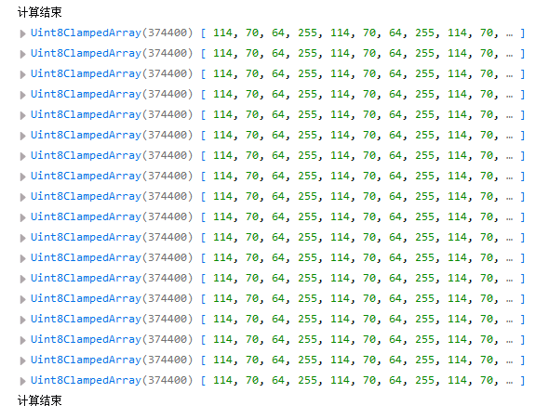

图 6

第三组数据18个

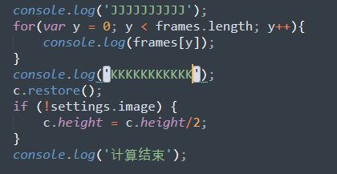

图 7

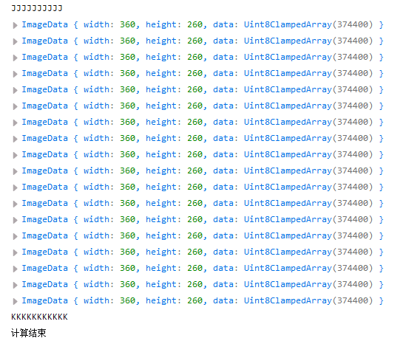

图 8 最终frames中的数据

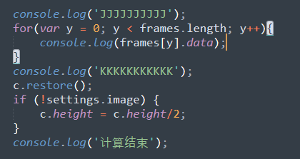

图 9

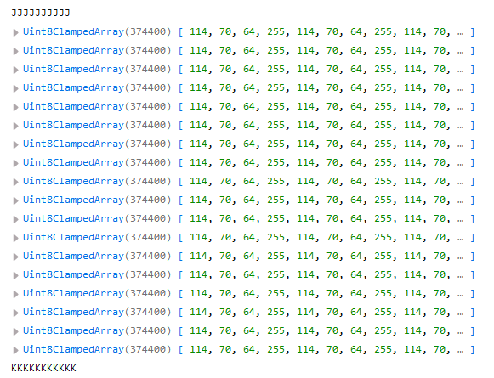

图 10

Frames中的数据也是重复的

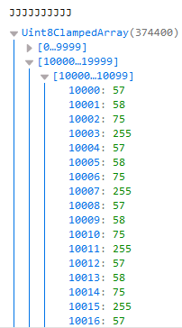

图 11

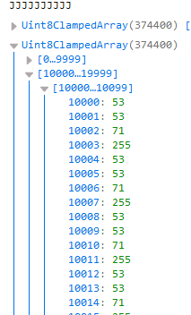

图 12

可是到中间就不一样了

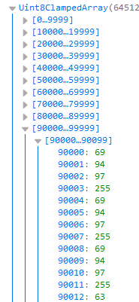

图 13

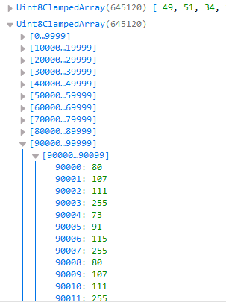

图 14

之前看似重复的数据其实不重复

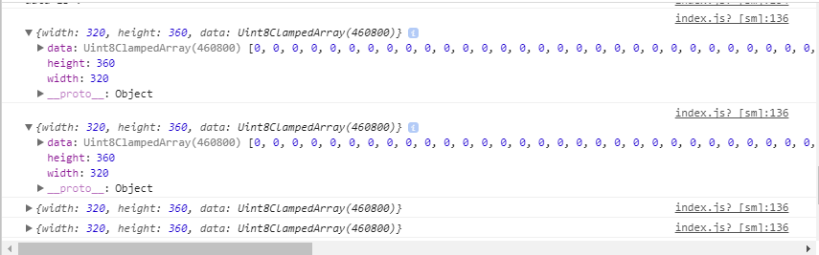

图 15

我的微信小程序中的frames全是0，包括最初的res都是0

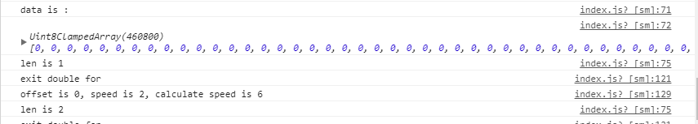

图 16

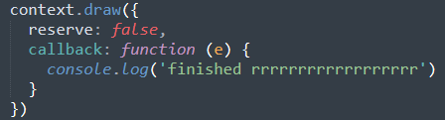

图 17

而且图 17中的callback也没有调用，没有打印出finish字样

该函数是一个回调函数，作图完成以后才会调用，我的GetImageData是在draw函数后面，而不是在callback中，采用异步执行的话，很有可能GetImageData在作图动作之前就完成了，读取了空白的画布像素。

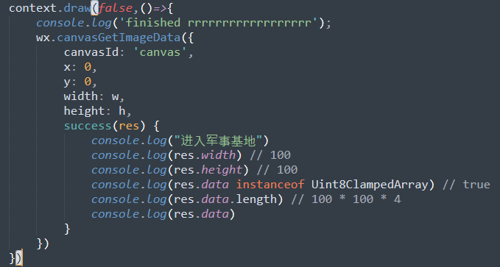

图 18

Draw函数要写成图 18中这样才行。